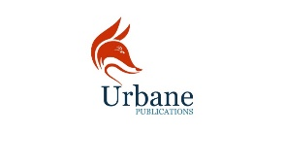

PRESS RELEASE
Matthew Smith
Publishing Director
matthew@urbanepublications.com
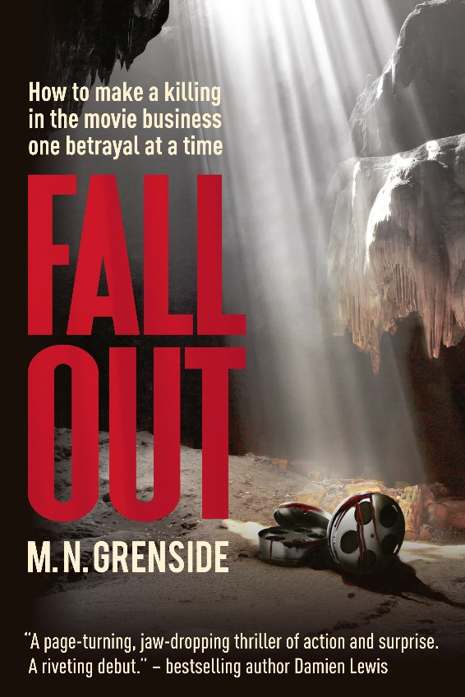
FALL OUT

By M.N.Grenside

May 2020 | £8.99 | Paperback Original | Urbane Publications Limited

“If you want a fast-paced, stand out, different thriller, I can’t recommend Fall Out enough. I Loved it.”

Emma Forbes, Broadcaster

Get Shorty meets The Da Vinci Code in this thrilling debut from Mark Grenside.

An LA screenwriter is killed shortly after completing his latest script, FALL OUT - a thriller destined to be a blockbuster but written with a secret double purpose.

Echoing events from the past the screenplay is sent to a very specific group of people and will change their lives forever. All are connected to a movie that had abruptly stopped shooting in the jungles of the Philippines years before. FALL OUT exposes the truth about a conspiracy and murder that led to a half-a-billion-dollar fortune for a select few.

Follow the story of Producer Marcus Riley, who sets out on an increasingly dangerous quest to get FALL OUT made. From a powerful Agent's office in Hollywood, hidden treasures in Belgravia and a remote chalet in the Swiss Alps to murder at the Cannes Film Festival, Marcus teams up with designer Melinda (Mako) de Turris as they and the other recipients of the screenplay are pursued by an assassin from the past.

With clues cleverly concealed in the screenplay, Marcus and Mako unravel a lethal puzzle that for some will bring death, others the truth and ends in a cave with a shocking secret...

- A page-turning international thriller driven by the author’s unique ‘insider knowledge’ of the film industry
- Based on the true scandal of a multi-billion-dollar theft and murder
- Meticulous and compelling research forms the basis of a gripping plot and characterisation

‘M.N.Grenside has written a splendid, page-turning first novel.’ – Peter Clark, Founder of Talk Radio

‘Truly fascinating historical fact buried in a thrill a minute read, all revealed with a lightness of touch that gave me a shiver of delight. I cannot recommend it enough.’ - Dawn Airey, former CEO Channel Five, Director of Content ITV, CEO Getty Images

‘Fall Out is a tautly written, entertaining thriller that will keep the reader turning the pages right till the very end. To borrow movie parlance, it sits somewhere between ‘The Da Vinci Code’ and ‘Indiana Jones’. -
Alan Moloney, award winning Producer, including Brooklyn, and the Oscar Nominated Albert Knobbs

‘Riveting. Page-turning. A jaw-dropping rollercoaster of action and surprise. And best off all, it's based upon shocking true history. A real gem.’ - Damien Lewis, international No. 1 bestselling author

‘A gripping thriller twisted around an incredible piece of recent history... and an equally fun glimpse into how our industry works! A well-researched ride.’ - Robert Halmi, Jr., Emmy and multi award winning Producer including Lonesome Dove, Tin Man and Merlin

‘A wonderfully fresh debut novel. The writer has created a group of diverse and believable characters in a deeply satisfying read, taking the reader to wonderful locations and a mind-blowing history lesson, all wrapped up in a page turning thriller. It may be a cliché, but I found it hard to put down.’ - Simon Oakes, CEO of Hammer Films

About the Author

Mark Grenside began his working career straight out of school at Lloyds of London, specializing in Kidnap, Ransom and Extortion Insurance. At 25 it was time for a career change and to dump the suit and tie, so he started his media career working for Jim Henson and The Muppets©. From that moment on he has been involved in Entertainment and nearly every aspect of it. He went on to create and produce several television series and mini-series. At the same time, he started a music management company launching million seller artist Neneh Cherry. In 2004 he arranged the US $250 million buy-out of the Hallmark Channel International which was then successfully sold to NBC. He returned to producing a number of movies and mini-series. He has recently morphed into a serial entrepreneur and is now a co-founder of seed to shelf CBD producer Dragonfly Biosciences and a founder in two separate digital companies. He is now writing the follow up to Fall Out, entitled The Bastion. In addition, he writes a humorous blog with subscribers in more than 40 countries. www.andanotherthing.com
He has two grown sons, two daughters’ in law, three grandchildren and lives in Malta with his wife, his collection of classic cars and two French bulldogs.

Fall Out
Author –M.N.Grenside
Publication – May 2020
Format - Paperback, £8.99
Isbn 9781912666751

For further information, interview and feature opportunities please contact:

Matthew Smith
Publishing Director
Urbane Publications
matthew@urbanepublications.com
+44 (0) 7578890446

